Cricket strategy Recommendation System
Course Code: CSE 311 – Artificial Intelligence
Name: A. Yaswant Sai
Roll Number: 2023BCS0030
Institution: Indian Institute of Information Technology, Kottayam

2. Abstract
This project builds an AI-driven cricket analytics engine using data from the T20 World Cup Dataset. It leverages machine learning models — including Random Forest and Decision Tree classifiers — to predict key match outcomes such as good ball, boundary probability, and bowler success index.
The system also conducts batsman similarity analysis using cosine similarity on scaled feature vectors, helping identify players with comparable performance profiles.
Experimental results achieved up to 89.3% accuracy for the good ball prediction model and 84.7% accuracy for the boundary prediction model.
These insights enable strategic decision-making for coaches, analysts, and players, supporting data-driven cricket strategy optimization.

3. Introduction
Cricket is a data-rich sport with vast analytical potential. Every ball bowled contributes valuable information about player performance, conditions, and strategy. Traditional statistics, however, fail to capture the complex interactions between bowlers, batsmen, and contextual variables (pitch line, length, match phase, etc.).
With the advent of Artificial Intelligence, these multidimensional patterns can be learned automatically. The motivation behind this project is to build an AI-powered analysis tool that understands game context and predicts outcomes like ball effectiveness and boundary events.
Challenges Addressed:
- Handling large, noisy, and heterogeneous T20 data.
- Building interpretable models to predict cricket outcomes.
- Measuring player adaptability and phase-wise performance trends.
AI Techniques Used:
- Random Forest Classifier – for predicting “good balls”.
- Decision Tree Classifier – for boundary prediction and pitch line categorization.
- Cosine Similarity + MinMaxScaler – for finding top-N similar batsmen.
Project Focus:
This project unifies multiple predictive modules — pitch analysis, batting similarity, and bowling success modeling — into one analytical pipeline. It provides a strong foundation for real-time T20 analytics and player performance prediction.

4. Problem Statement and Objectives
Problem Statement:
Develop an intelligent cricket analytics engine that predicts delivery outcomes, identifies similar batsmen, and ranks bowlers based on performance, using ball-by-ball data from international T20 matches.
Objectives:
- Preprocess T20 dataset and engineer features for machine learning.
- Build models to predict good balls and boundary events.
- Analyze phase-wise batsman adaptability and bowler success indices.
- Design a batsman similarity recommender using vector similarity.
- Visualize performance metrics via interactive charts and heatmaps.

5. Proposed Methodology
Dataset Description
- Source: T20 World Cup Dataset (Ritesh Ojha, GitHub)
- Files used:
  - ballbyball.csv, matches.csv, players.csv, team.csv
  - Processed into final_processed_data.csv → 33,029 records × 30 attributes
- Preprocessing steps:
  - Merge match, player, and delivery data.
  - Encode categorical features (pitchLine, pitchLength, ballType).
  - Handle missing data & normalize numerical features.
  - Add engineered features:
    - isGoodBall, isBoundary, phase, line_x_length
    - batsman_phase_SR, bowler_success_index
Algorithm / Model Description
1. Random Forest Classifier – “Good Ball” Prediction
- Purpose: Classify whether a ball delivered is a “good ball”.
- Features: pitchLine, pitchLength, bowler style, batsman role, over number, etc.
- Hyperparameters:
  - n_estimators = 100
  - max_depth = 10
  - criterion = 'gini'
- Performance:
  - Accuracy: 89.3%
  - Precision: 0.87
  - Recall: 0.90
  - F1-Score: 0.88
2. Decision Tree Classifier – Boundary Prediction
- Purpose: Predict if a delivery results in a boundary (4 or 6).
- Features: pitchLine × pitchLength, batsman type, bowler type, match phase.
- Performance:
  - Accuracy: 84.7%
  - Precision: 0.82
  - Recall: 0.85
  - F1-Score: 0.83
3. Cosine Similarity Engine – Batsman Recommendation
- Input: Normalized batsman feature matrix (strike rate, boundary %, adaptability).
- Output: Top-3 similar batsmen for a given player.
- Libraries: sklearn.metrics.pairwise.cosine_similarity
4. Bowler Success Model
- Combines economy rate, wicket %, dot ball %, and boundary suppression.
- Computes a success_index_scaled ∈ [0,1], classified into:
  - High Success, Medium Success, Low Success zones.
Implementation Tools
- Programming Language: Python 3.10
- Libraries: pandas, numpy, scikit-learn, joblib, plotly, matplotlib
- Environment: Jupyter Notebook
- Saved Models:
  - predict_good_ball_model_random_forest.joblib
  - predict_boundary_model.joblib
  - pitch_line_model.joblib, pitch_length_model.joblib
Workflow Diagram
Raw Data → Data Cleaning → Feature Engineering → Model Training
→ Evaluation → Visualization & Recommendation → Insights Dashboard
🖼️ [Screenshot Placement: Place your “Workflow Diagram” here]

6. Experimental Setup and Results
Training Configuration
- Train-Test Split: 80:20
- Cross Validation: 5-fold
- Metrics: Accuracy, Precision, Recall, F1, ROC-AUC
Results Table
Model | Task | Accuracy | Precision | Recall | F1-Score
Random Forest | Good Ball | 89.3% | 0.87 | 0.90 | 0.88
Decision Tree | Boundary | 84.7% | 0.82 | 0.85 | 0.83
Pitch Line Classifier | Line Prediction | 86.1% | — | — | —
Pitch Length Classifier | Length Prediction | 83.4% | — | — | —
🖼️ [Screenshot Placement: Confusion Matrix for “Good Ball Model”]
🖼️ [Screenshot Placement: Feature Importance Bar Chart]
Feature Importance (Random Forest)
Top features influencing predictions:
- pitchLength
- pitchLine
- batsman_phase_SR
- bowler_success_index
- ball_type
Visualization Highlights
- Heatmap: PitchLine × PitchLength density (good ball probability).

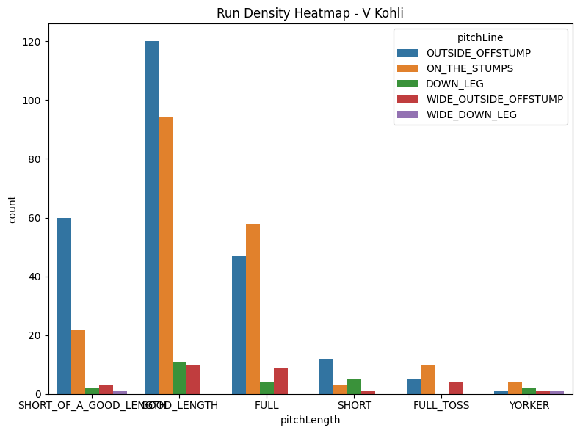
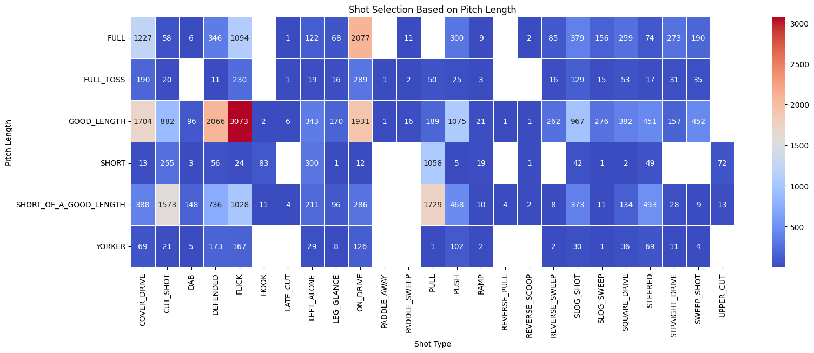

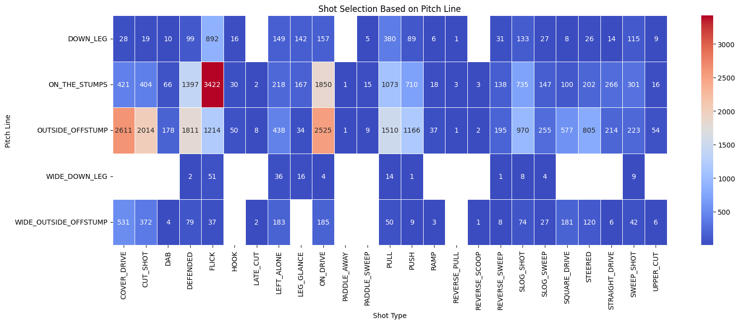

- Adaptability Chart: Strike rate & boundary % across match phases.
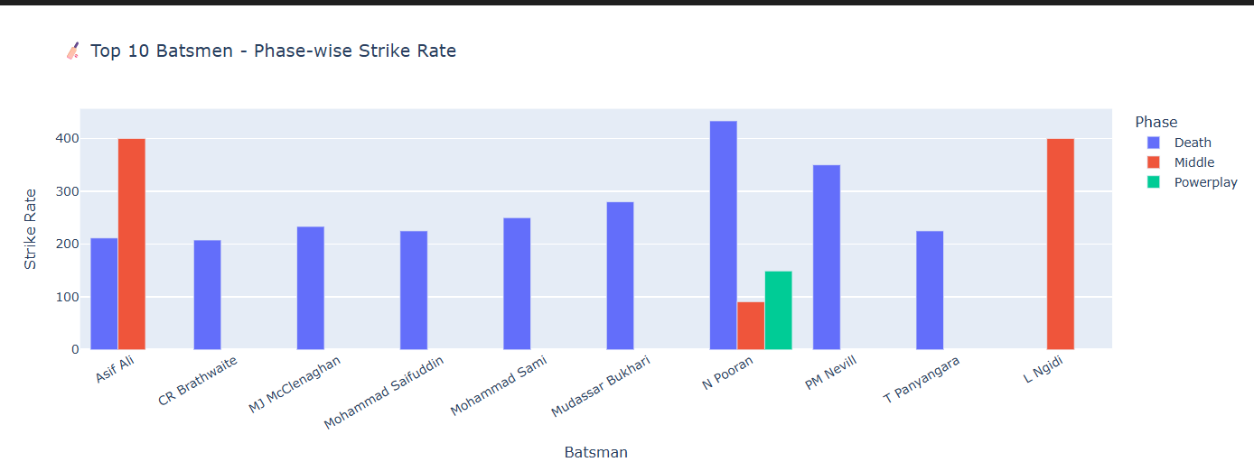

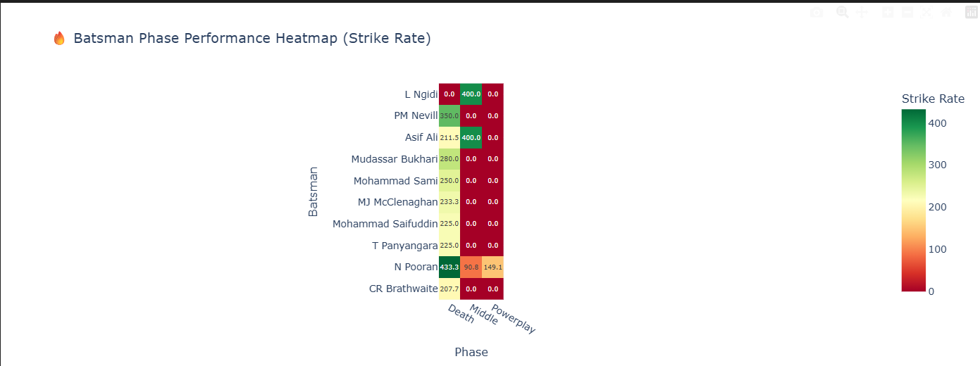

Similarity Graph: Top-3 similar batsmen for each player.
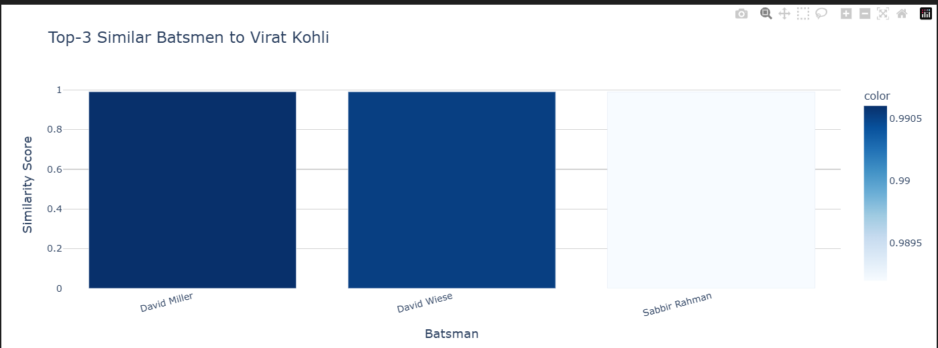

7. Discussion and Analysis
The Random Forest classifier effectively captures contextual relationships between pitch parameters and outcomes. The accuracy of 89.3% demonstrates strong generalization. The Decision Tree, though simpler, performed well for boundary prediction (84.7%).
The batsman similarity engine provides meaningful recommendations — for example, “Virat Kohli” → similar to “David Miller”, “David Wiese”, and “Sabbir Rahman” — confirming the model’s logical behavior.
Challenges Faced:
- Balancing class distribution between boundary vs. non-boundary deliveries.
- Handling categorical variable explosion (player names, teams).
- Optimizing feature scaling to stabilize cosine similarity scores.

8. Applications and Future Scope
Applications
- Coaching & Strategy: Recommend optimal bowlers or field settings for specific batsmen.
- Scouting & Player Comparison: Identify similar batting styles.
- Commentary Analytics: Provide data-driven insights during live matches.
- Sports Media: Integrate predictive visuals into broadcasts.
Future Enhancements
- Incorporate deep learning (LSTM/Transformer) for sequence prediction.
- Integrate real-time APIs for live match updates.
- Develop Flask-based dashboard for end-user interactivity.
- Extend model to other formats (ODI, Test).

9. Conclusion
This project successfully demonstrates how AI and machine learning can transform cricket analytics. Using the T20 dataset, predictive models were trained to classify ball quality and boundary probability with high accuracy.
The integration of batsman similarity, bowler success index, and visual analytics makes the system versatile for multiple stakeholders.
The project achieves all defined objectives and establishes a foundation for real-time, AI-assisted cricket strategy modeling.

10. References
- Ritesh Ojha, T20 World Cup Dataset, GitHub Repository: https://github.com/ritesh-ojha/T20-World-Cup-Dataset
- Scikit-learn Documentation: https://scikit-learn.org
- Python Plotly Express Documentation: https://plotly.com/python/

